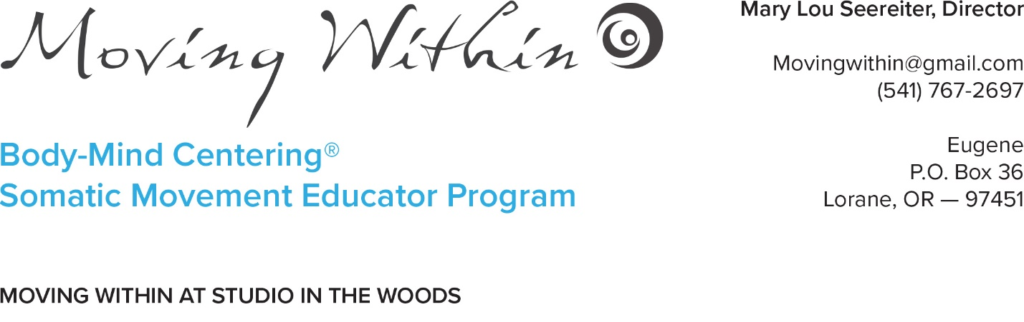
Greetings and Welcome! We, the faculty and staff, would like to know about you in order to enhance your participation in the SME program or individual course. Hopefully, completing this application will help you become clearer about yourself, what you bring to the program, what you need for support, and what your goals and expectations are. Thank you for your time; we look forward to meeting you.
Do not send money until Mary Lou confirms that there is a spot available for you. At that time, she will send you a payment plan to reserve your spot. If you have any questions please contact: movingwithin@gmail.com or (541) 767-2697
- Name
Address
Email
Phone number
Date of birth
- Are you interested in pursuing the certification in the Somatic Movement Education Program or are you interested in taking one course independently? What course or courses would you like to register for?
- What is your educational background? Please list any post-secondary schools attended, dates and any degrees or certificates you received. You may enclose a resume if you prefer.
- What is your work experience or other significant experience? Again you may enclose your resume.
- What experience (if any) have you had with Body-Mind Centering®? How did you first hear about BMC®? Have you had individual session, classes or workshops with a Certified Practitioner? Who? Approximately, how many hours?
- Please list your experience with other body-mind disciplines (movement, dance, bodywork, other psychophysical approaches). Indicate whether your experience has been casual, serious amateur, semi-professional or professional.
- How did you hear about this course/program at Moving Within? What is your goal in taking this course or program? What are your expectations?
- This program is experiential in nature. You will be working with yourself and closely with other individual participants and with the group as a whole. What are your experiences in working in groups? What is your experience in working in duets or trios?
- There will be three teachers in each course representing a range of teaching styles some of which may be unfamiliar to you. Do you know what your learning style is (auditory, visual, kinesthetic, intellectual)? Within the group of participants, there will also be many learning styles. How will this be for you? What are your strengths and talents? What are the areas where you might need support?
- Do you have any physical or emotional conditions that could affect your participation in this program? Can you describe?
- Is there anything else that you would like us to know about you?
- Do you have any concerns about your participation in this program?
- Please indicate and sign an acknowledgment: “With my signature I acknowledge that I take full responsibility for any injuries that may result from participation in this workshop. Photos may be taken during the course to use as publicity material such as the Moving Within website. My signature indicates my permission to use these photos unless I notify in writing before the workshop or on the last day of the workshop that I do not want my photos used.“
- Please go to the ACCOMODATIONS page to view options for where to stay during the course.
Date________________________Signature___________________________________

MOVING WITHIN CANCELLATION POLICY AND ADMINISTRATIVE FEES.
There will be a $50 processing fee for each and every change requiring administrative tasks.
Cancellation later than two months before the course is scheduled: refund or credit towards another course only if your spot can be filled. The refund or transfer if the spot is filled will be minus $50 for administration fee.

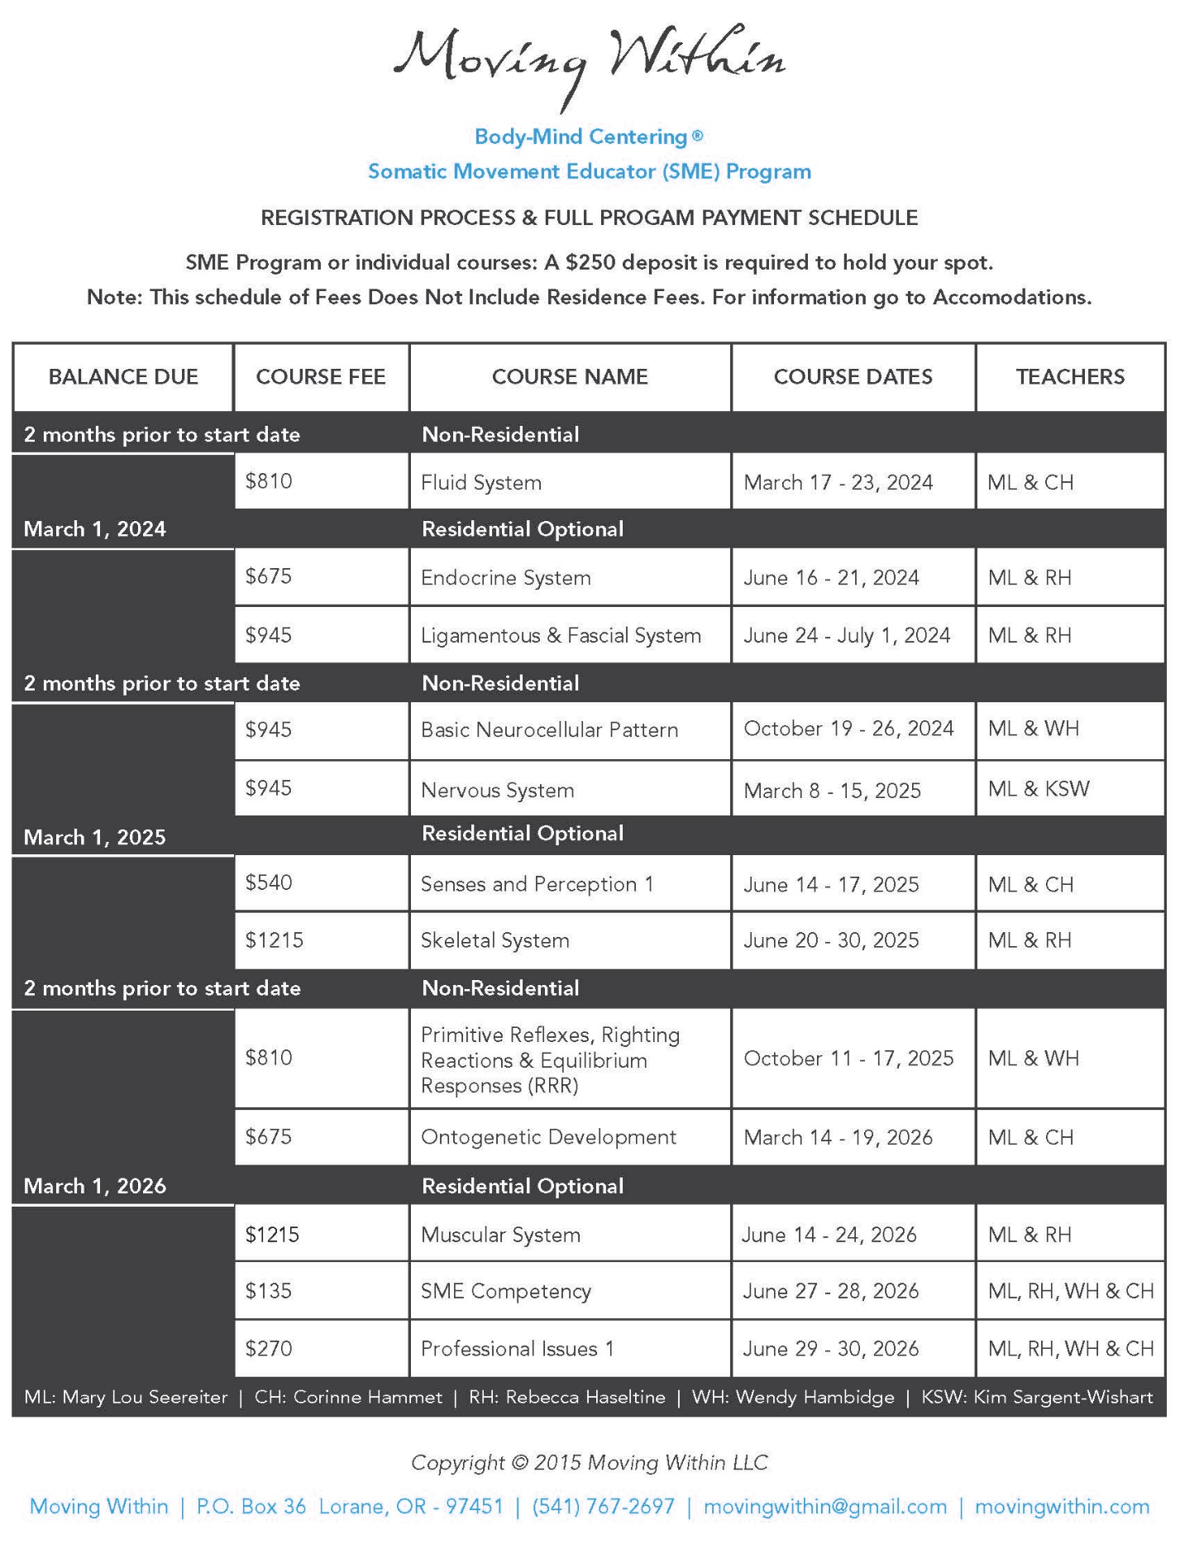
and Body-Mind Centering® are registered service marks and BMC®
is a service mark of Bonnie Bainbridge Cohen, used with permission.

